Great, I look forward to the experiment. I have created two data sets in google BQ. In order to give you access I'll need your email address. By accessing this data you agree that this data is only to be used for Outsite Networks experiments and that all data will be deleted following the conclusion of the experiments. Here the BQ summary of the data sets:

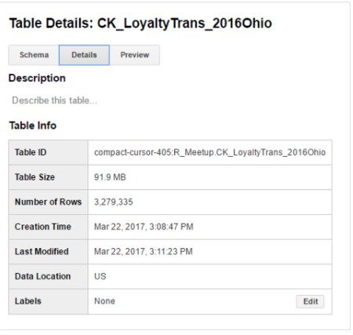Small data Large data

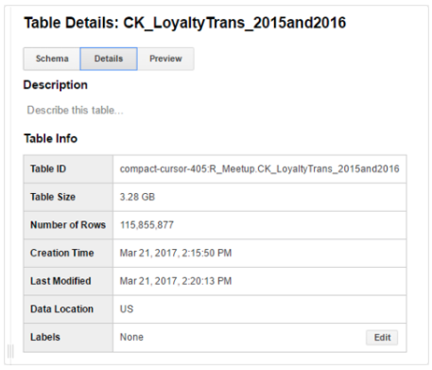

Schema

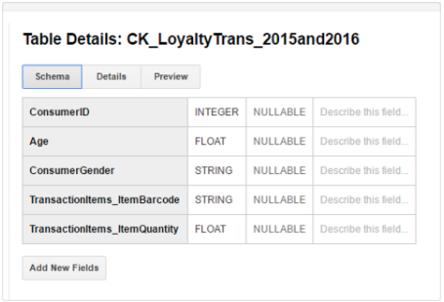

I'll have to create an additional data set with meta data about: TransactionItems_ItemBarcode

*Some ideas for initial projects, I'm sure you guys will have additional ideas:

* Select a barcode -- > Receive consumer demographic information regarding that barcode: %gender, age graph, gender % by age. These two items would fall under a consumer demographic info topic.
* An additional topic could be: basket analysis e.g. Consumer who purchases X also purchased A,B,C,D
* A third topic could be: Consumer brand affinity based on the barcode meta data hierarchy

The barcode meta data hierarchy is as follows:

* NACS product category classification (National Association of Convenience Stores)
* NACS sub category
* Product manufacturer
* Product Brand
* Product name

I will provide a file with the meta data for 27,000 barcodes (UPCs) (edited)

Brand affinity would measure purchases at each level (1 through 5) and report reductions to higher levels - lack of loyalty. For example:

* Beer - QTY 100
* Imports - QTY 80
* Miller Coors - QTY 60
* Selected Miller Brand - QTY 40
* Selected Miller product - QTY 30

This would indicate 10 other miller products from selected brand are purchased, 20 in other miller brands, 20 other imports, and 20 other beer products.

++++++++++++++++++++++++++++++++++++++++++++++++++++++++++++++++++++++++++++++++++

Hackaton - Projects:

* Shopper profile:
  + Given UPC set in from fancy filter (set A)
  + Output: Gender%, age curve, age slider gender % bonus
* Basket
  + People who purchased from set A also purchased set B,C,D
* Affinity
  + Lower level(set A) segment QTY as percent of higher level segment QTY
* Recommend engine
  + People who by A should buy B,C (promote B,C)

Factors:

* Target product input flexibility
  + Segmentation filter
  + Multi filter
* Output clarity (segmented) with what if scenarios bonus
* NBA (Next Best Action) recommendation engine
* Performance, scalability
* Algorithm
* Shiny UI bonus
* Surprise finding
* Multi-team implementation

Prize:

1. $500
2. $400
3. $300 Best surprise finding

qty3 x $100 best in category